VENUE BOOKING FORM (1 of 2)

When signed by the Client named below, this document constitutes an agreement between Shoreditch London Ltd (SL) and the Client for the hire of the specified areas of the premises and the Hire Period set out on the Booking Form, together with the attached Terms and Conditions.

This contract is not assignable by the Client to any other party without the prior written consent of SL. Consent may be refused for any reason.

No booking will be deemed confirmed until the Deposit Payment is paid and a Booking Form signed by the Client is received and acknowledged by SL.

Date of Agreement
Client Name
Address
Phone
Email
Booking Dates
Booking Times
Estimate Guest Attendance
Venue Address | 29 New Inn Yard, EC2A 3EY (Night Time)
 | 37 Batemans Row, EC2A 3HH (Day Time)

VENUE BOOKING FORM (2 of 2)

Space(s) being hired and Fee
Studios 1 & 2 on the above date | £6,000+VAT

Additional Charges
Damage Waiver (refundable) | £1,500
SIA Registered Security Personnel  (Required for the duration of the Wedding, 30 minutes either side of guest arrival/departure. 1 guard must stay on site until the venue is locked down) | £17+VAT p/h, p/guard
Duty Manager | Included
Waste Removal | 2x1110 ltr bins TBC
PA System in Studio 1 & Studio 2 | Included
Basic House Lighting | Included
Basic WiFi (Technician required for anything other than casual use // 100Mb up/down available) | Included
Post event cleaning | Included

Payment schedule for initial fees
 | Amount | Date Due
Deposit Payment | £3,000 +VAT (Hire Fee deposit) | On Confirmation
Balance Payment | £3,000 +VAT (Hire Fee balance)
Final Payment | TBC +VAT (Additional Fees)  £1,500 (Damage Waiver)

Catering Requirements
None required internally, Client will be sourcing Catering and staffing externally. We ask that you ensure the Caterers remove all waste from the space and use the bins provided. The venue should be left in the condition prior to hire.

Timetable for installation and removal of Client’s furniture, equipment or effects

Get In/Rig-in | – Access from
De-Rig/Strike | – Cleared by

Shoreditch London named contact and contact details
John O’Malley (General Manager)
Tel: 020 7033 9006

We hereby agree to be bound by the terms out above.

Signed by ………………………………………………… (For and on behalf of Client)

Date …………………………………………………

Please send back one copy of the signed booking form to link@shoreditch.com
TERMS & CONDITIONS (1 of 4)

These are the terms and conditions that Shoreditch London Ltd (SL) and the Client have agreed in relation to the provision by SL to the Client of the specified areas of the premises and facilities, and for the Hire Period set out on the Booking Form.

1. Dates and Times
1.1 The Date, Start Time and End Time for the Event are as set out in the Booking Form.

1.2 Any changes to the timings of the Hire Period or any deliveries / pickups outside of the Hire Period must be requested in writing by the Client and agreed with SL. This may incur additional charges.

1.3 The Client shall ensure that all guests have left the Premises by the End Time and if the Client fails to do so, SL shall be entitled to charge the Client for each hour or part of an hour after the End Time at the hourly rate applicable to each room (any such payment shall be referred to in this Contract as “Late Charges”)

1.4 Late Charges will also apply to any access to or use of the venue before the contracted start time of the Hire Period on the date of hire.

1.5 Late Charges per hour (See Clauses 1.3 + 1.4) – Studio 1: £150 + VAT // Studio 2: £150 + VAT

2. Fees and Payments
2.1 The Client shall pay SL the Initial Fees, any Additional Fees and any Late Charges and in accordance with the Booking Form.

2.2 Damage Waiver will be charged at £1,500.

2.3 If credit facilities have not been agreed prior to commencement of the booking, cleared payment will be due 1 calendar month prior to the event.

2.4 Payment is accepted by cash, credit/debit card or bank transfers.

2.5 SL does not dispose of sets or props, and there is no storage provided post-event without written consent by SL. In the event of sets, props or lighting set ups being left in the studios, we reserve the right to make appropriate charges for de-rig and disposal at your expense. SL will not accept liability for any loss or damages to any items left at the venue by the Client before or after the Event.

2.6 The Client shall remove all rubbish bags and empty bottles and glasses from the space and leave space in the condition prior to hire. If the Client fails to do so, additional charges may be applied.

2.7 In this Contract, “Initial Fees” refers to the fixed amounts agreed as at the date of the Contract as set out in the Booking Form and “Additional Fees” refers to amounts for which the Client is liable under the terms of this Contract but are not as yet quantified.

2.8 All payments due under this Contract are payable without any deduction or set-off, including, without limitation, any losses, expenses, claims or damages suffered or incurred from the acts or defaults of the Client, its agents, officers, sub-contractors, and guests.

2.9 If the Client fails to make any payment in full on the due date, interest is also payable on any outstanding amount at the rate of 2% (Two Percent) above the base rate of HSBC from time to time from the due date until the date of payment (both dates inclusive) whether before or after judgement.

2.10 The parties agree that Clause 2.9 above is a substantial remedy under section 8 of the Late Payment of Commercial Debts (Interest) Act 1998.

3. Maximum Room Capacity
3.1 Studio 1: 200 persons // Studio 2: 150 persons

3.2 The Client agrees to ensure that the maximum capacity for any room is not exceeded.

3.3 The Client acknowledges and agrees that SL shall be entitled to refuse entry to any individual where the admission of such individual would bring the total number of individuals above the maximum capacity.

4. Catering Requirements
4.1 If the Client wishes to exceed the Catering Requirements, the Client shall notify SL in writing (which may include by e-mail) of any additional catering requirements specifying the menu selection or menu selections and the number of heads for each menu selection at least 5 Business Days (“Business Day shall mean Monday to Friday inclusive, excluding any public holiday or bank holiday in England and Wales) prior to the Event. Such notification must be sent to the person named on the Booking Form. The Client shall be obliged to pay an Additional Fee for the additional catering requirements based on SL’s price list.

4.2 If that the Client makes a verbal request for additional Catering Requirements during the Event, SL shall provide such catering subject to availability and staff capacity and the Client will pay an Additional Fee or Additional Fees for such additional catering based on SL’s price list. Any verbal requests on behalf of the Client shall only be made by the individual or individuals named on the Booking Details.

5. Cancellation
5.1 Any cancellation must be made in writing (which may include by email) and shall be deemed to be received on the date on which it is received by SL where such receipt is before 18.00 hours on a Business Day and shall otherwise be deemed to be received on the next following Business Day of actual receipt by SL. Any notice of cancellation must be sent to the person named on the Booking Form.

5.2 If the Client wishes to postpone an Event this can only be affected by making a written cancellation and rebooking the Event, subject to availability.

5.3 In the event of any no-show, the Event shall be deemed cancelled on the day on which it was due to take place.

5.4 In the event of a cancellation by the Client, all deposits paid will be retained by SL in accordance with the below Notification Period structure. The Client shall be liable to pay a cancellation fee, which shall be a percentage of the Initial Fee as follows:

Notification Period | Cancellation Fee
More than 91 days | 25%
46-90 days | 50%
45 days or less | 100%

5.5 In the event that SL incurs any costs, charges or penalties as a result of having entered into any contracts with third parties relating to any services, supplies, equipment or the like in relation to the Event and the total amount for which SL is liable exceeds the cancellation fee, the Client shall pay an amount equivalent to such excess to SL.

5.6 The Company may invoice the Client for any cancellation fees at any time after the cancellation taking into account the amount of any deposit already paid.

5.7 In the event of the following COVID-19 pandemic-related restrictions and rules imposed by Government agencies on the Event Date(s), at the request of the Client, the Company will waive the Notification Period outlined in 5.4, and offer a postponement of the Event Date(s). If the Company cannot offer an appropriate alternative Event Date(s) due to the nature of the Event, the booking will be cancelled with no Cancellation Fee payable.
1) Prohibition of Wedding ceremonies and receptions in England.
2) Restriction of attendance below the Estimate Guest Attendance at Wedding ceremonies and receptions.
3) Requirement of social distancing and/or the wearing of masks at Wedding ceremonies and receptions.
4) Prohibition of dancing at Wedding receptions and celebrations.
5) Restriction of international and domestic travel resulting in guests unable to attend.

6. Provision of Staff
6.1 SL shall not provide specialist personnel such as technicians, commissionaires, toastmasters and the like unless this is specified on the Booking Form or expressly agreed with the Client in writing.

6.2 All Staff, third parties or contractors engaged by the Client must be sufficiently trained to ensure a proper standard of observance and performance of all regulations, fulfilment of the terms of this agreement and the on-going good conduct of all attendees.

6.3 The Client shall appoint a representative of the Client who shall be available at all times to deal with any enquiries and emergencies and to ensure that all guests attending the Event comply with Clause 8 below.

7. Provision of Equipment
7.1 Equipment to be provided by SL free of charge is as set out in the Booking Form.

7.2 SL shall provide any additional equipment requested by the Client as specified on the Booking Form and Client shall pay SL Additional Fees for such equipment being the actual cost of the equipment together with an administrative charge which may vary depending upon the client’s event requirements.

7.3 The Client shall only use any mechanical or electrical equipment on SL’ premises with the prior written consent of SL which shall be subject to the Client giving SL sufficient time to carry out all testing deemed necessary by SL, compatibility of any such equipment for use at SL’ premises (such as, without limitation, the availability of power supplies and the feasibility of installation of equipment in a safe manner) and the Health & Safety at Work Act 1974 and all relevant regulations.

7.4 The Client shall only bring any furniture, equipment or effects on SL’ premises as set out in the Booking Form or with the prior written consent of SL (which SL may refuse at its absolute discretion). The Client is responsible for removal of all such furniture, equipment or effects and at the discretion of SL agrees to make good any damage caused by the installation or removal of such furniture, equipment or effects or to pay the full reasonable cost of doing so. The Client shall install and remove such furniture, equipment or effects in accordance with the timetable set out in the Booking Form or as otherwise set out by SL in advance in writing.

7.5 The Client, its employees, agents, officers, sub-contractors and guests must not make any alteration or addition to the Venue whatsoever, without prior written consent of SL.

8. Client Conduct
8.1 The Client agrees to observe all instructions and code of conduct set out by SL and, without limitation, agrees to take all steps to ensure that no damage is caused to SL’ premises or property, that no illegal activity is carried out and that no aggressive behaviour is displayed.

8.2 The Client agrees not to affix anything to the doors, walls, ceilings or columns of the premises without the prior written consent of SL, which shall be at the absolute discretion of SL.

9. Compliance with Legal Requirements & Regulations
9.1 The Client agrees to ensure all license, registrations and statutory consents for the Event and for any services to be provided (other than by the Company) are in full force and effect.

9.2 If the Event function involves the performance of literary or musical works and/or the playing or showing of copyright sound recordings, films, broadcasts or other material, the Client warrants that it will prior to the date of the function obtain all necessary licences or permissions including those required under the Copyright Designs and Patents Act 1988 and shall indemnify the Company against any liability incurred by the Company arising as a result of any failure to obtain such licences or permissions.

9.3 The Client warrants that it will comply with all legal and regulatory requirements, rules, regulations and industry guidelines from time to time in force in the UK in using and occupying the Premises and in connection with the Event (including without limitation all health and safety, hygiene, disability and environmental requirements).

9.4 SL does not permit the Client to bring into or place in the Venue or surrounding grounds any helium balloons, confetti, glitter bombs, fireworks or other flammable, combustible, dangerous or objectionable items, substances or liquids. Certain items may be acceptable but only with prior written approval from SL.

9.5 The Client must provide to SL evidence of sufficient safety certificates and relevant Risk Assessments prior to the Event Date. All production appliances must only be used by trained individuals.

10. Advertising & Publicity
10.1 The Client shall not use the name, trademark or logo of SL in any publicity, advertising or promotion of the Event without the Company’s prior written consent other than for the purpose of indicating the location of the Event. The client shall not use the name, trademark, logo or address of SL prior to written confirmation of event date and payment of deposits.

10.2 SL reserves the right to feature the Client’s company name and/or logo on SL’s website and marketing material. If the Client does not wish to be featured, a written notice must be served by the Client prior to the Event.

10.3 SL reserves the right to use professional pictures and/or videos taken by the Client or third parties during the Hire Period for marketing purposes. SL will consult and liaise with the Client prior to use of individual imagery.

11. Indemnity
11.1 The Client shall indemnify and keep indemnified SL, its employees and/or agents against any and all losses, damages, costs, claims, demands or other liabilities suffered by or made against SL, its employees and/or agents arising from or in connection with any breach of this Contract.

11.2 Without prejudice to the generality of Clause 11.1 above, in the event that the Client cancels the Event, the Client shall reimburse SL for all and any expenditure incurred by SL in relation to the Event, including any future payments such as cancellation charges or penalties, to the extent that such sums are not already covered by the Cancellation Fee set out in Clause 5.

12. Termination / Cancellation of Event by Shoreditch London
12.1 SL shall be entitled to terminate this Contract with immediate effect by serving written notice on the Client in the event that any payment due under this Contract is more than ten (10) days overdue.

12.2 The Client must fully and accurately disclose to SL the purpose and nature of the Event and if such disclosure is not complete or accurate, SL shall be entitled to terminate this Contract at its absolute discretion with immediate effect by serving written notice on the Client.

12.3 If SL terminates the Contract under this Clause 12, no refund shall be made to the Client of any monies already paid and the remainder of the Initial Fee shall be payable.
13. Limitation of liability
13.1 SL does not exclude or restrict its liability in respect of death or personal injury resulting from its negligence or as a result of any fraudulent misrepresentation.

13.2 SL shall not be liable for any loss, damage, cost or claim as a result of any delay in performance or non performance of its obligations under this Contract, to the extent that the delay or non performance is due to an event beyond its reasonable control (including, without limitation, act of God, outbreak of hostilities, riot, civil disturbance, acts of terrorism, the act of any government (including refusal or revocation of any licence or consent), fire, explosion, flood, power failure, failure of telecommunication lines, independent acts of its agents or sub-contractors, any strike, lock out or other form of industrial action).

13.3 Subject to Clause 13.1 above, SL’ liability for any loss or damage as a result of breach of contract or tort (including negligence) or otherwise including but not limited to any direct, indirect, consequential or economic losses or loss of profits howsoever arising shall not in any event exceed one and a half times the Initial Fees set out in the Booking Form.

14. Insurance
14.1 The Client shall unless otherwise agreed by the parties in writing effect and maintain at its own expense with an insurance company of repute public liability insurance and insurance in respect of any liability which it may incur, in each case for such sum and range of cover as it shall deem appropriate (including but not limited to strikes, civil disturbances, acts of terrorism, war or threat of war, or power failure) but not less than £5,000,000 (five million) for any one incident or series of related incidents.

14.2 The Client shall ensure that SL’ interest is noted on the policy of insurance and the policy shall be shown to SL upon reasonable request together with satisfactory evidence of the payment of premiums.

15. Notices
15.1 Any notice to be given under or in connection with this Contract shall be in writing (which may include by email) and shall be delivered by hand, or sent by post or by fax to such person, address or fax number as either party may notify to the other from time to time by notice in writing. Such notice shall be deemed served if sent by hand upon delivery, if sent by first class post two working days after delivery and if sent by fax, on receipt of the fax confirmation provided always that a copy of any notice sent by fax is also sent by first class post on the date of transmission of the fax.

16. General
16.1 Each of the provisions contained in this Contract is independent of every other such provision so that if any such provision is determined to be illegal, invalid and/or unenforceable, such determination will not affect any other provision of this Contract, all of which will remain in full force and effect.

16.2 The headings in this Contract are for convenience only and do not form part of the Contract.

16.3 Any failure to exercise or delay in exercising a right or remedy under this Contract shall not constitute a waiver of the right or remedy or of any other rights or remedies.

16.4 The Contracts (Rights of Third Parties) Act 1999 shall not apply to any contract between the parties in respect of the Event.

16.5 In the event of any dispute, the parties agree to enter into good faith negotiations to reach a resolution, failing which the matter shall be referred to mediation using the services of the Centre of Dispute Resolution. If the dispute cannot be resolved by negotiation or mediation, either party may then commence action in the English Courts.

16.6 This Contract is governed by the laws of England and the English courts shall have exclusive jurisdiction.

Appendix A

Restricted Areas
All vehicle and public activities in the yellow shaded area on the map is restricted to 19h45.
All vehicles must be removed from this area no later than 19h45.

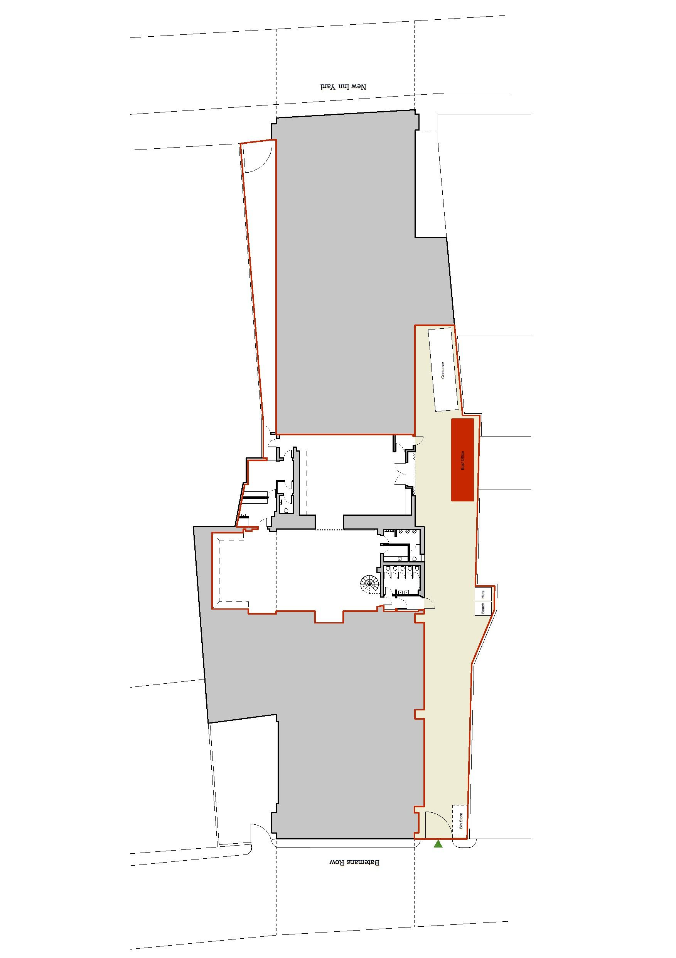
Appendix B

Electrical Specifications
63 Amps 3 phase x 3
The client is advised to supply a distribution box to accommodate all supplied equipment. The client is discouraged from using all other sockets other than those specified above to avoid power outage due to faulty appliances.

Hanging Truss
4 x Tri-Truss - Load per Truss is 500 Kg. You are encouraged to use the installed trusses, however we also ask you to remove excess tapes off the truss and leave no dog-ears.

Wall Mounts
Tension wires are provided along the walls of the studios for the client use. These are tested to 100 kg and are useful for hanging frames, photographs, paintings etc. We ask clients to refrain from drilling into our walls and we also discourage the use of production tapes on the walls as these are inclined to leave residue or peel off paint.

Audio
Each studio is equipped with an audio system suitable for speech and background music.
Internal sound or music levels must not exceed levels of 82dBA in Studio 1 / 98dBA in Studio 2 and comply with the Code of Practice on the Environmental Noise Control at Concerts (1995) for indoor venues.

Lighting
Studio 1 is fitted with 3x 650 watts Fresnel lights on dimmers. Studio 2 is fitted with 2x 650 watts Fresnel lights.

Security Personnel
In-house SIA security personnel supervise events at all times. However on special occasions, at the discretion of the Duty Manager, there is provision for additional security staff supplied by the client.

Catering
Cooking is not permissible inside the premises. No forms of flammable gas or liquids are permissible within the premises. Electric ovens are permitted inside the studios at the discretion of the Duty Manager.

Method Statement
SL requires all clients to submit method statements and production schedule and call sheets no later than 7 days before each proposed event.

